 | Part of the Paper | Research Studies | Key ideas and course book references
 | Paper 1: Language and the Individual.  Students should explore how children develop their spoken and written skills. To achieve this, students should study:  The functions of children’s language  phonological, pragmatic, lexical, semantic and grammatical development  different genres of speech and writing  different modes of communication (spoken, written, multimodal)  theories and research about language development. | The Stages of Language Development: | 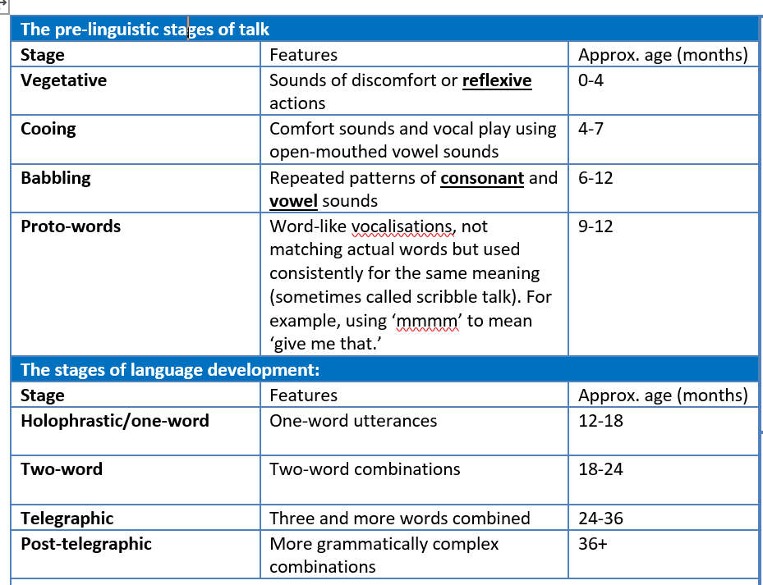
 |  | Halliday’s Functions of Language (1975) | Several attempts have been made to catalogue the different functions of language, and to chart child language development in terms of the increasing range of these functions to be found in the growing child’s repertoire. Michael Halliday’s taxonomy is documented below:-  -Instrumental: Language used to fulfil a need on the part of the speaker. Directly concerned with obtaining food, drink and comfort.  - Regulatory: Language used to influence the behaviour of others. Concerned with persuading / commanding / requesting other people to do things you want.  - Interactional: Language used to develop social relationships and ease the process of interaction. Concerned with the phatic dimension of talk.  - Personal: Language used to express the personal preferences and identity of the speaker. Sometimes referred to as the ‘Here I am!’ function – announcing oneself to the world.  - Representational: Language used to exchange information. Concerned with relaying or requesting information.  - Heuristic: Language used to learn and explore the environment. Child uses language to learn; this may be questions and answers, or the kind of running commentary that frequently accompanies children’s play.  - Imaginative: Language used to explore the imagination. May also accompany play as children create imaginary worlds, or may arise from storytelling.
 |  | Noam Chomsky – Innateness/Nativism (1957) | There is an ongoing argument within linguistics as to whether language acquisition is innate or learned. Chomsky theorized that language is an innate ability or function within the human brain.  One of the factors in Chomsky’s theory is the fact that there is an optimal learning age (between the ages of 3 to 10) and that outside of this time it is harder, even impossible, for a person to grasp a language in its entirety. This is backed up by the case of Genie, who at the age of 13 was unable to grasp anything beyond basic word strings and never fully developed the ability to communicate fluently.  He also believes that we are pre-programmed to develop language and that we possess a Language Acquisition Device (LAD).  Chomsky also found it significant that different languages shared similar grammatical traits (universal grammar) despite their differences in phonology and lexis.
 |  | B. F. Skinner – Behaviourism (1957) | Skinner provided one of the earliest theories of language acquisition (1957). He believed that language development could be accounted for by environmental influence.  Skinner’s particular branch of behaviourism was called ‘radical behaviourism’ This was the philosophy of looking at the science of behavior and the idea of environmental factors reinforcing different behaviours.. Reinforcement is seen as a central concept of behaviourism, and an essential mechanism in the shaping and control of behavior. Positive reinforcement is the strengthening of a behavior by offering a reinforcing stimulus (e.g. Vivos for holding open a door), negative reinforcement is the removal or avoidance of an aversive event (putting on a coat on a cold day to avoid being cold).  Skinner argued that children learn language based on behaviourist reinforcement principles by learning to associate words with meanings. When they use language correctly this is reinforced by them being able to communicate the meaning to those around them, for example asking for a banana will mean they receive attention and the named object from a caregiver. The child will find this rewarding thus enhancing their linguistic development.
 |  | Jean Piaget – Cognitive Theory (1926) | Piaget believed that children are born with an inherited and genetically evolved mental structure which all learning and development stems from. His theory was not exclusively centered on language development, but rather the developmental processes that children go through.  Piaget did not believe that intelligence was a fixed point but rather that cognitive development was supported by interaction with the environment as well as being a part of the maturing process. He proposed discrete stages for development and was focused on how children develop the ability to reason and apply hypotheses to the world around them.  He also supported the idea of ‘readiness’ and that a child had to be at the right stage developmentally to acquire a skill or ability. He also developed the idea that children learn best through actively exploring ideas and concepts rather than having theme explained to them.  Piaget theorized that every child went through the same stages in the same order. He did not, however, ascribe a certain age to the different stages, even though they are often seen with these.
 |  | J. Bruner – Social Interactionist Theory (1983) | Bruner emphasized the importance of social interaction in helping children to acquire language. He coined the term LASS (Language Acquisition Support System) which refers to a child’s social support network. Bruner highlighted the importance of adult interaction in developing children’s language.  Bruner believed that with the right scaffolding and support children would be able to develop not only their language use, but any skill or understanding of a concept. He highlighted the role of structured, helpful interaction in supporting a child to achieve a specific goal.  '[Scaffolding] refers to the steps taken to reduce the degrees of freedom in carrying out some task so that the child can concentrate on the difficult skill she is in the process of acquiring' (Bruner, 1978, p. 19).  Bruner believed that with the right scaffolding a child could grasp a concept usually only understood by adults.
 |  | Jean Berko – The Wug Test (1958) | Jean Berko devised the Wug Test as part of her research in 1958 to test children’s grasp of grammatical rules. She used nonsense words and made-up animals to test the children’s ability to pluralise using the regular form (adding –s to the end of fictional common nouns). She also conducted experiments in other common grammatical functions e.g. adding –ed to make a verb past tense or adding –er to the end of verbs to create nouns.  Berko found that from a very young age children had a grasp of grammatical rules and were able to use the endings to create grammatically correct utterances. This implies that children have an internalised understanding of grammatical concepts.  However, in younger children Berko found that children could only apply the rules to words they already knew, suggesting that there is an element at the start of children memorising key words.
Word |  | Definition
Communicative Competence |  | The ability to creative meaningful speech or writing.
Non-Verbal Communication |  | Gestures, Haptics (Touch), Paralanguage (stress, amplitude, speed), Eye Contact and Facial Expressions -these are the main ones for a child.
Reduplication |  | Repeated syllables within a word Such as moo-moo or wee wee
Diminutives |  | The reduction is scale of an object through addition of extra suffix e.g. Doggie, Dolly More accessible and phonologically easier or more appealing to say.
Substitution |  | The process of swapping one sound for another that is easier to produce.
Assimilation |  | One consonant or vowel is swapped for another
Deletion |  | Omitting a particular sound within a word
Consonant cluster reduction |  | Reducing phonologically complex units into simpler ones - from two or more consonants down to one.
Operant conditioning |  | A positive or negate ve response given by caregiver can influence the way a child speaks in the future.
Positive reinforcement |  | The positive feedback given to a child which is thought to encourage similar performance again.
Language Acquisition Device |  | Proposed by Chomsky. All humans are born with an innate language capacity.
Tabula Rasa |  | Latin for "blank slate" and the term used to describe the idea that children are born with undeveloped, fresh brains.
Universal Grammar |  | Term coined by Chomsky -the idea that all human languages possess similar grammatical properties which the brain is "hard -wired" to decode and use.
Virtuous errors |  | Grammatical errors that are understandable and logical through an incorrect assumption being made about grammar rules.
LASS Language Acquisition Support System |  | Proposed by Bruner. A system whereby caregivers and other individuals who play a key role in a child's language development.
Scaffolding |  | The support provided by caregivers through modelling how speech ought to take place in order to help language development.
CDS Child directed speech |  | The various ways in which a caregiver (unconsciously) adapts their speech in order to aid a child in language development.
Recast |  | The grammatically incorrect utterance of the child is spoken back to the child but in the correct form.
Mitigated imperatives |  | An instruction given in such a way that it does not appear to be a command but a more gentle suggestion
MKO More knowledgeable other |  | The older participant in an interaction who might offer support to a child so they can further their own developmental learning. Vygotsky.
ZPD Zone of proximal development |  | Describes the area between what a child can already do and that which is beyond their reach. Caregiver might enable child to progress by offering support. Vygotsksy.
Overextension |  | When a child uses a word more broadly than intended to describe things other than the actual item to which the word applies.
Underextension |  | Where a child might use a word more narrowly to describe something without recognising the word has a wider use.

